Use this template if your project is a group project for two students.

Name of Team Member:
Jacob Hillebrand
Alison Zimmerman

Project Descriptions:

For this project, we are planning to use both the Digilent Keypad and the LCD module to create a timer on the FreedomBoard-KL25Z. The user will be able to use the keypad to set a timer on the keypad, with functionalities such as setting the time, starting the timer, stopping the timer, and resetting the timer.

Concept sketches: (e.g. flow charts, wiring diagrams, or anything else you have to describe your designs)

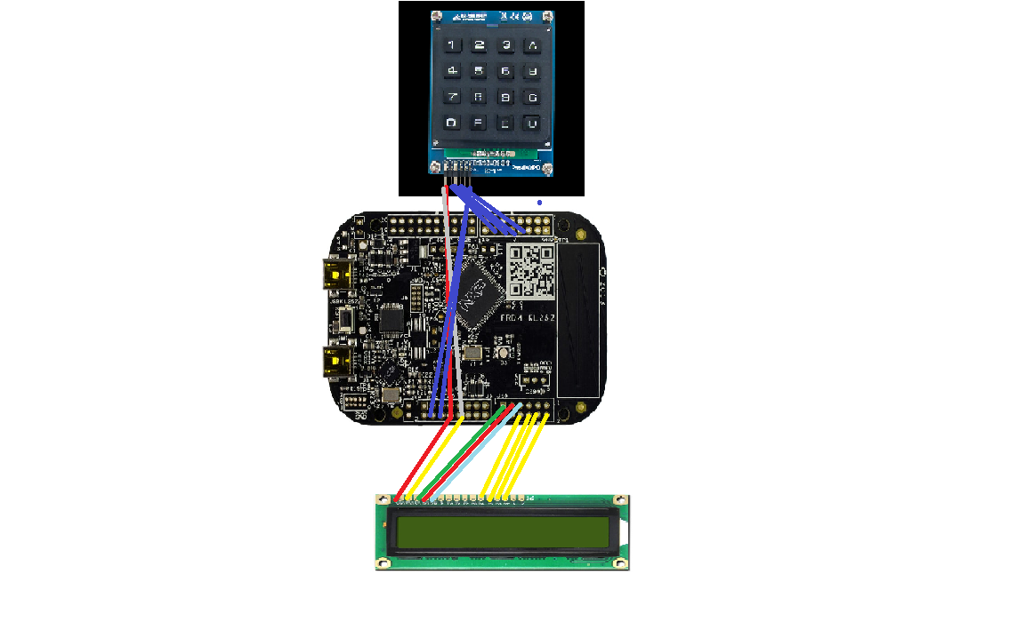

*Note: Pins are subject to change as development occurs, but this is the general idea.

Bill of Materials:

Part: | Cost:
FRDM-KL25Z board | Provided ($38.99)
LCD Module | Provided ($26.00)
Digilent Keypad | Provided ($9.99)
Wiring | Provided ($1.95)
Total | Provided ($76.93)

Project Grading Rubric:

